Tutorial 1/Assignment 2
Brand Management

- Formation of Groups for Assignment 1
- Activity 1: Brand Positioning (30 Minutes)
  - Form the group of three
  - Meet the UOL students
  - Ask following questions
- List Down five famous brands, and ask them what they think (what comes in their mind) after listening the name of that brands
- Brand Mantra for any three brands
- Your favorite brand and why you like that particular brand
- The Brand you don’t like and why

- Activity 2: Design Associative Network Memory Model for a Brand
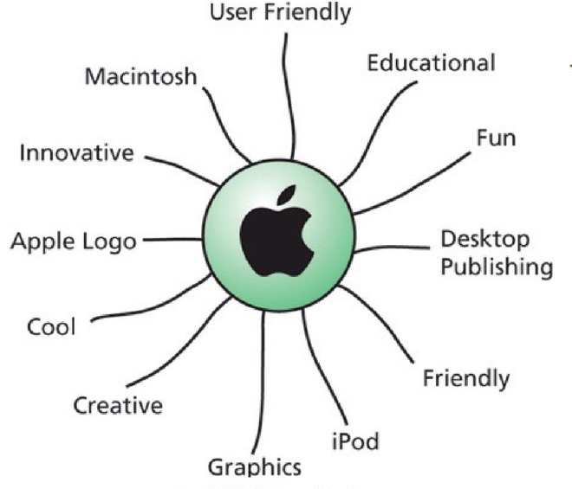
Example:


