Minutes of Meeting

Date: October 25, 2050
Time: 10:00 AM - 11:30 AM
Location: Conference Room 1A

Attendees
- John Smith - Project Manager
- Jane Anderson - Senior Developer
- Robert Johnson - UX Designer
- Emily Davis - QA Tester
- Michael Brown - Business Analyst

Agenda
- Project Status Update
- Review of Last Week's Action Items
- Upcoming Milestones
- QA Testing Feedback
- Open Floor Discussion

Minutes

1. Project Status Update
John Smith provided an update on the project's current status. The development phase is 80% complete, and we are on track to meet the next milestone. No significant issues were reported.
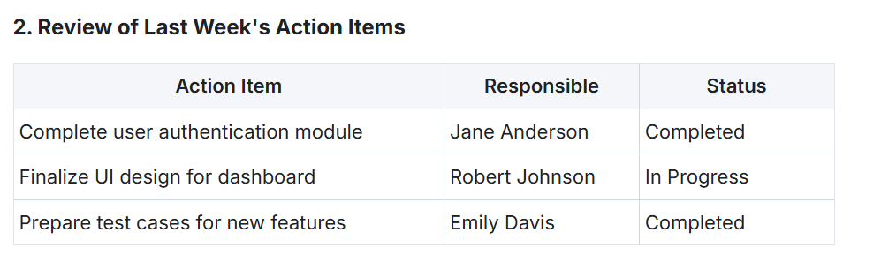

3. Upcoming Milestones
- November 1, 2050: Finalize UI Design
- November 10, 2050: Complete System Integration Testing
- November 20, 2050: Stakeholder Review

4. QA Testing Feedback
Emily Davis shared the feedback from the initial round of QA testing. The majority of the functionalities are working as expected, with minor bugs found in the reporting module. These issues are being addressed.

5. Open Floor Discussion
Michael Brown raised a point regarding the resource allocation for the upcoming sprint. The team agreed to re-evaluate the workload and make necessary adjustments.

